ADDITIONAL QUESTIONS:
1]
#include<stdio.h>
#include<stdlib.h>
struct Node{
int data;
struct Node* next;
};
// Create node
struct Node* newNode(int val){
struct Node* temp = (struct Node*)malloc(sizeof(struct Node));
temp->data = val;
temp->next = NULL;
return temp;
}
// Reverse between m and n
struct Node* reverseBetween(struct Node* head, int m, int n){
if (!head || m == n) return head;
struct Node dummy;
dummy.next = head;
struct Node* prev = &dummy;
// Move prev to (m-1)th node
for (int i = 1; i < m; i++)
prev = prev->next;
struct Node* start = prev->next;
struct Node* then = start->next;
// Reverse between m and n
for (int i = 0; i < n - m; i++){
start->next = then->next;
then->next = prev->next;
prev->next = then;
then = start->next;
}
return dummy.next;
}
// Print list
void printList(struct Node* head){
while (head){
printf("%d ", head->data);
head = head->next;
}
printf("\n");
}
int main(){
struct Node* head = newNode(1);
head->next = newNode(2);
head->next->next = newNode(3);
head->next->next->next = newNode(4);
head->next->next->next->next = newNode(5);
printf("Original list: ");
printList(head);
head = reverseBetween(head, 2, 4);
printf("Reversed (2 to 4): ");
printList(head);
return 0;
}
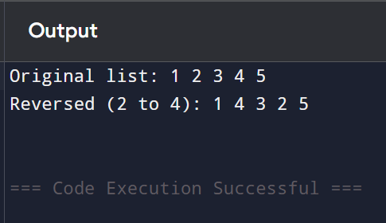

2]
#include<stdio.h>
#include<stdlib.h>
struct Node{
int data;
struct Node* next;
};
struct Node* newNode(int val){
struct Node* temp = (struct Node*)malloc(sizeof(struct Node));
temp->data = val;
temp->next = NULL;
return temp;
}
// Rotate list right by k places
struct Node* rotateRight(struct Node* head, int k){
if (!head || k == 0) return head;
struct Node* temp = head;
int len = 1;
// Find length & last node
while (temp->next){
temp = temp->next;
len++;
}
temp->next = head; // Make circular
k = k % len;
int steps = len - k;
// Move to (len-k)th node
while (steps--)
temp = temp->next;
head = temp->next;
temp->next = NULL;
return head;
}
void printList(struct Node* head){
while (head){
printf("%d ", head->data);
head = head->next;
}
printf("\n");
}
int main(){
struct Node* head = newNode(1);
head->next = newNode(2);
head->next->next = newNode(3);
head->next->next->next = newNode(4);
head->next->next->next->next = newNode(5);
printf("Original: ");
printList(head);
head = rotateRight(head, 2);
printf("Rotated by 2: ");
printList(head);
return 0;
}
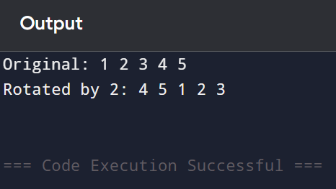

3]
#include<stdio.h>
#include<stdlib.h>
struct Poly{
int coeff, pow;
struct Poly* next;
};
struct Poly* newNode(int c, int p){
struct Poly* temp = (struct Poly*)malloc(sizeof(struct Poly));
temp->coeff = c;
temp->pow = p;
temp->next = NULL;
return temp;
}
struct Poly* addPoly(struct Poly* p1, struct Poly* p2){
struct Poly* res = NULL;
struct Poly* tail = NULL;
while (p1 && p2){
struct Poly* temp;
if (p1->pow > p2->pow){
temp = newNode(p1->coeff, p1->pow);
p1 = p1->next;
} else if (p2->pow > p1->pow){
temp = newNode(p2->coeff, p2->pow);
p2 = p2->next;
} else {
temp = newNode(p1->coeff + p2->coeff, p1->pow);
p1 = p1->next;
p2 = p2->next;
}
if (!res){
res = temp;
tail = res;
} else {
tail->next = temp;
tail = tail->next;
}
}
while (p1){
if (!res){
res = newNode(p1->coeff, p1->pow);
tail = res;
} else {
tail->next = newNode(p1->coeff, p1->pow);
tail = tail->next;
}
p1 = p1->next;
}
while (p2){
if (!res){
res = newNode(p2->coeff, p2->pow);
tail = res;
} else {
tail->next = newNode(p2->coeff, p2->pow);
tail = tail->next;
}
p2 = p2->next;
}
return res;
}
void printPoly(struct Poly* head){
while (head){
printf("%dx^%d ", head->coeff, head->pow);
if (head->next) printf("+ ");
head = head->next;
}
printf("\n");
}
int main(){
struct Poly* p1 = newNode(3, 3);
p1->next = newNode(2, 2);
p1->next->next = newNode(1, 0);
struct Poly* p2 = newNode(4, 3);
p2->next = newNode(3, 2);
p2->next->next = newNode(2, 1);
printf("Polynomial 1: ");
printPoly(p1);
printf("Polynomial 2: ");
printPoly(p2);
struct Poly* sum = addPoly(p1, p2);
printf("Result: ");
printPoly(sum);
return 0;
}
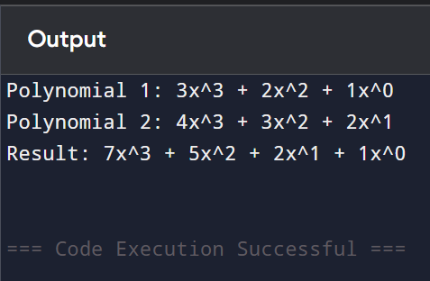

4]
#include<stdio.h>
#include<stdlib.h>
struct Node{
int data;
struct Node* next;
};
struct Node* newNode(int val){
struct Node* temp = (struct Node*)malloc(sizeof(struct Node));
temp->data = val;
temp->next = NULL;
return temp;
}
int getIntersection(struct Node* h1, struct Node* h2){
struct Node *a = h1, *b = h2;
while (a != b){
a = (a == NULL) ? h2 : a->next;
b = (b == NULL) ? h1 : b->next;
}
return a ? a->data : -1;
}
int main(){
// Common part
struct Node* common = newNode(15);
common->next = newNode(30);
// List 1
struct Node* h1 = newNode(3);
h1->next = newNode(6);
h1->next->next = newNode(9);
h1->next->next->next = common;
// List 2
struct Node* h2 = newNode(10);
h2->next = common;
printf("Intersection Node Data: %d\n", getIntersection(h1, h2));
return 0;
}
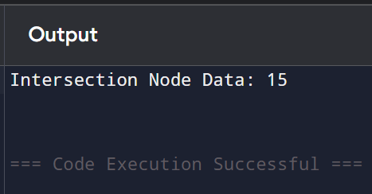

5]
#include<stdio.h>
#include<stdlib.h>
struct Node{
int data;
struct Node *left, *right, *up, *down;
};
// Create a new node
struct Node* newNode(int val){
struct Node* temp = (struct Node*)malloc(sizeof(struct Node));
temp->data = val;
temp->left = temp->right = temp->up = temp->down = NULL;
return temp;
}
// Construct doubly linked list from 2D matrix
struct Node* constructDLL(int mat[][10], int rows, int cols){
struct Node* head = NULL;
struct Node* rowStart = NULL; // first node of each row
struct Node* prevRowStart = NULL;
for (int i = 0; i < rows; i++){
struct Node* prev = NULL;
for (int j = 0; j < cols; j++){
struct Node* curr = newNode(mat[i][j]);
if (i == 0 && j == 0)
head = curr;
// Connect left <-> right
if (prev){
prev->right = curr;
curr->left = prev;
}
// Connect up <-> down
if (prevRowStart){
struct Node* upNode = prevRowStart;
for (int k = 0; k < j; k++)
upNode = upNode->right;
curr->up = upNode;
upNode->down = curr;
}
if (j == 0)
rowStart = curr;
prev = curr;
}
prevRowStart = rowStart;
}
return head;
}
// Print matrix using right and down pointers
void printDLL(struct Node* head, int rows, int cols){
struct Node* row = head;
for (int i = 0; i < rows; i++){
struct Node* col = row;
for (int j = 0; j < cols; j++){
printf("%d ", col->data);
col = col->right;
}
printf("\n");
row = row->down;
}
}
int main(){
int mat[10][10];
int r, c;
printf("Enter rows and columns: ");
scanf("%d %d", &r, &c);
printf("Enter matrix elements:\n");
for (int i = 0; i < r; i++)
for (int j = 0; j < c; j++)
scanf("%d", &mat[i][j]);
struct Node* head = constructDLL(mat, r, c);
printf("\nDoubly Linked List representation (printed as matrix):\n");
printDLL(head, r, c);
return 0;
}
